Food Management System

Use-Case-Realization Specification: Choose Product

Version <1.0>

Revision History

|  |  |  |  |
| --- | --- | --- | --- |
| **Date** | **Version** | **Description** | **Author** |
| <24/12/2020> | <1.1> | Final Draft | Nguyen Thi Ngoc Anh |

Table of Contents

1. Introduction 2

1.1 Purpose 2

1.2 Scope 2

1.3 Definitions, Acronyms, and Abbreviations 2

1.4 References 2

1.5 Overview 2

2. Flow of Events—Design 2

3. Derived Requirements 2

Use-Case-Realization Specification: Choose Product

# Introduction

## Purpose

This document describes how the Choose Product Use-Case is realized within the design model, in terms of collaborating objects.

## Scope

This document applies to the Food Management System which will be developed by TAT Restaurant.

## Definitions, Acronyms, and Abbreviations

None.

## References

None.

## Overview

In the following section, Use-Case Realization Specification of the Choose Product Use-Case of the Food Management System is provided in detail. The first section is a textual description of the Use-Case specification. The following section contains diagrams (sequence and collaboration diagrams) describing how the use case is realized in terms of collaborating objects. The third section includes class diagrams with relationships that participate in the realization of the use case. The last section is an analysis of all requirements, such as non-functional requirements, on the use-case realization that are not considered in the design model, but that need to be taken care of during implementation.

# Flow of Events—Design

**2.1. Use Case Specification (script)**

|  |  |
| --- | --- |
| **Use Case** | Choose Product |
| **Description** | A customer chooses products based on search and/or filtering options |
| **Actor(s)** | Customer |
| **Flows of Events** |  |
| **Basic Flow** | |
| 1. The user goes to home page.  2. The system get all products in database as a list.  3. The user select one or more products.  4. The system displays all selected products in the list for the user | |
| **Alternative Flows** | |
| None. | |
| **Pre-conditions** | |
| The user is in display products page. | |
| **Post-conditions** | |
| A page lists all selected products in database is displayed for the user. | |
| **Extension Points** | |
| None. | |

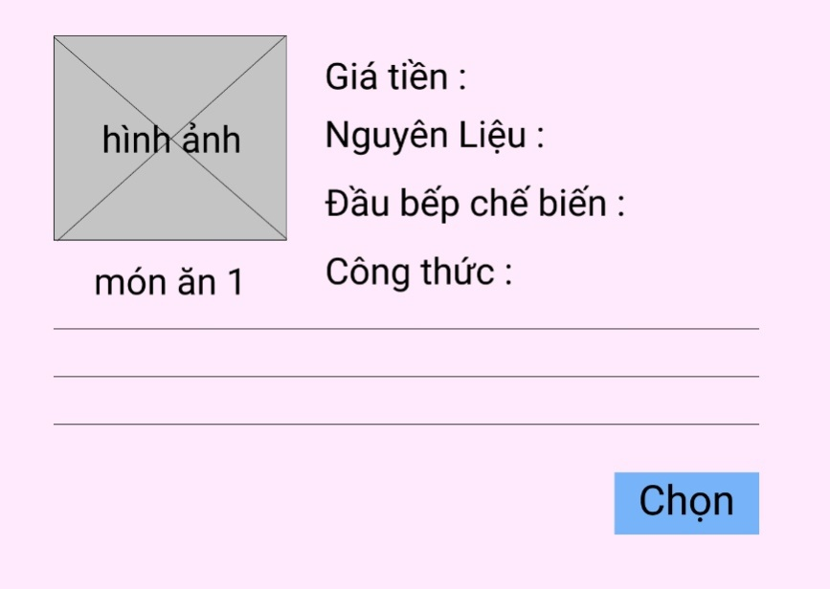

you selected this product

**2.2. Sequence Diagram:**

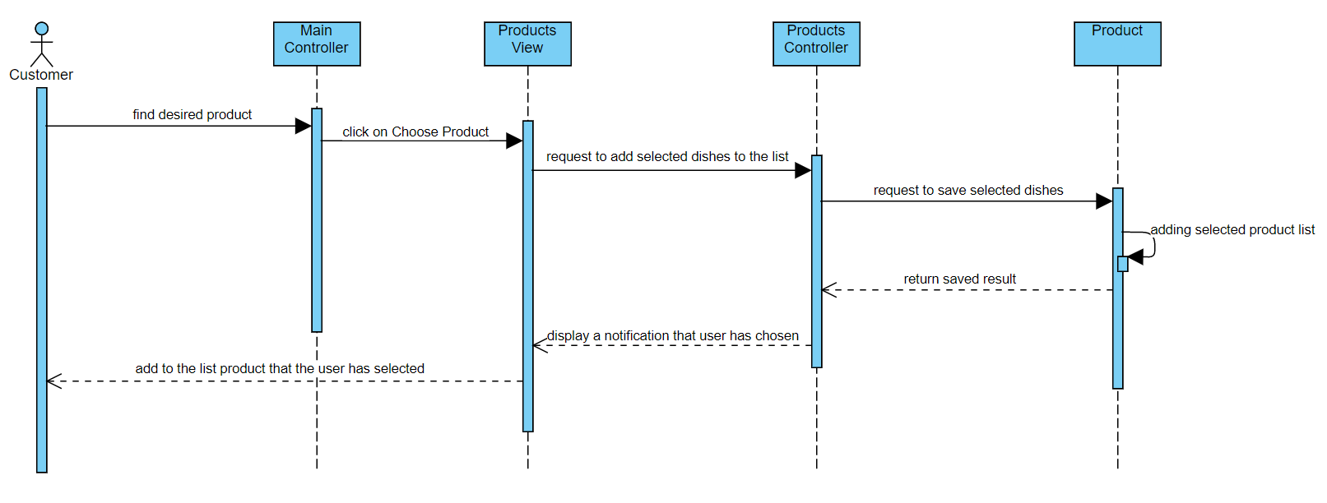

**2.3. Class Diagram:**

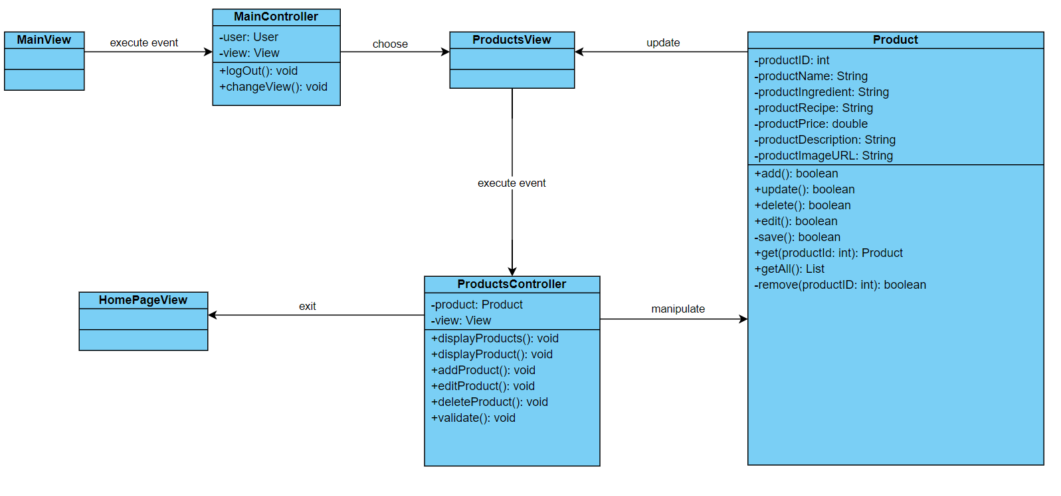

# Derived Requirements

None.